**Answer Sheet - SQL**

Name : Pankaj Roy

Batch No. : 5

Phone No. : 7980968739

Email : roypankaj5432115@gmail.com

**Major Question 1**

1. List the salary of all the employees.

<answer-here>select ENAME,SALARY from EMPLOYEE;

Insert Image-

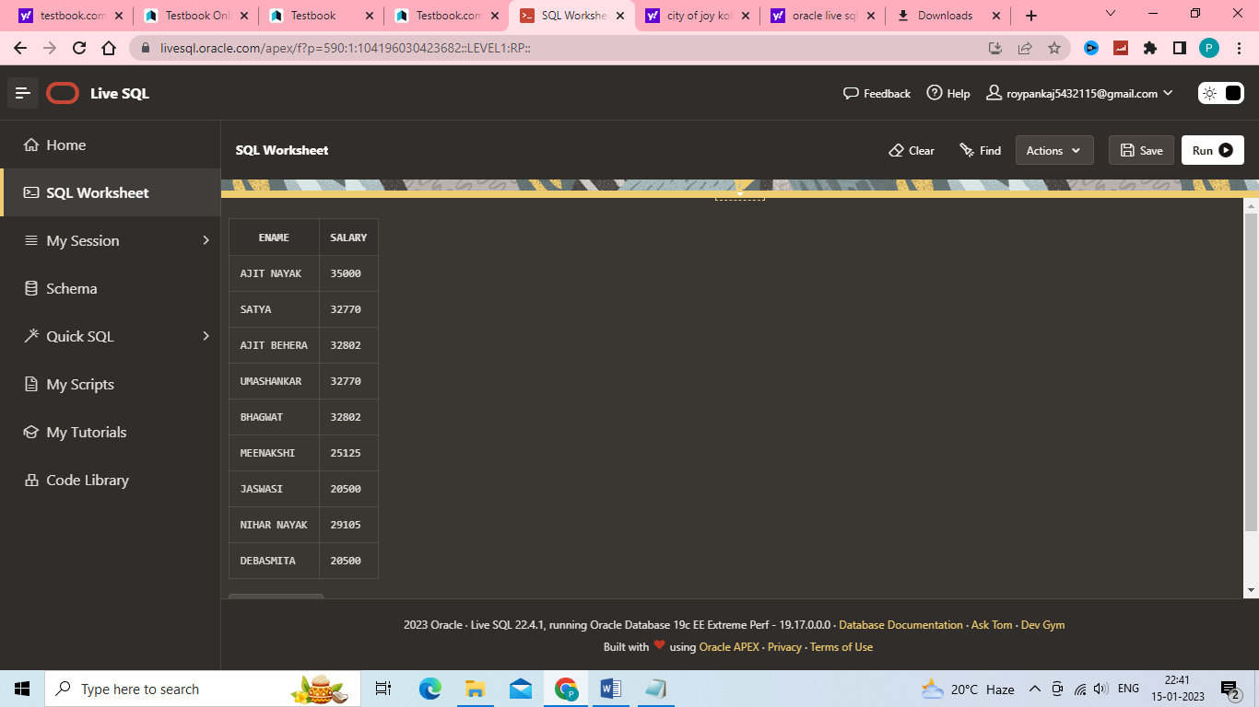

1. Display the names of all employees with any “A” at any place of the name.

<answer-here>select ENAME AS "Employee Name" from EMPLOYEE where ENAME like '%A%';

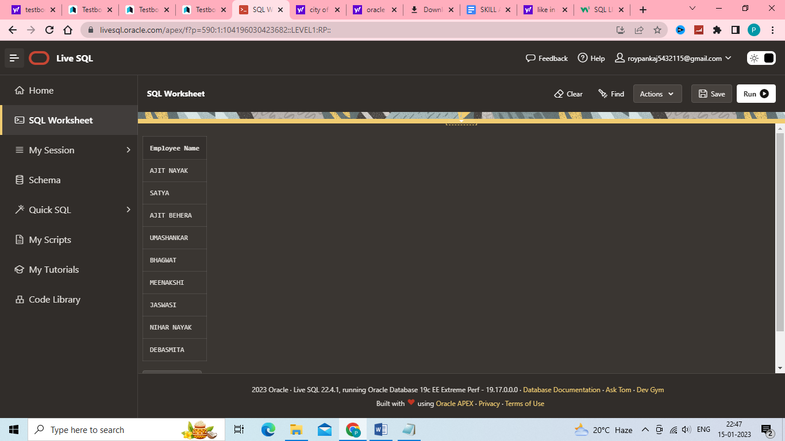Insert Image –

1. Show all employees who were hired in the first half of the month (Before the 16th of the month).

<answer-here> select * from EMPLOYEE join DEPARTMENT using(MGRSRNO) where extract(day from MGRSTARTD)<16;

Insert Image -

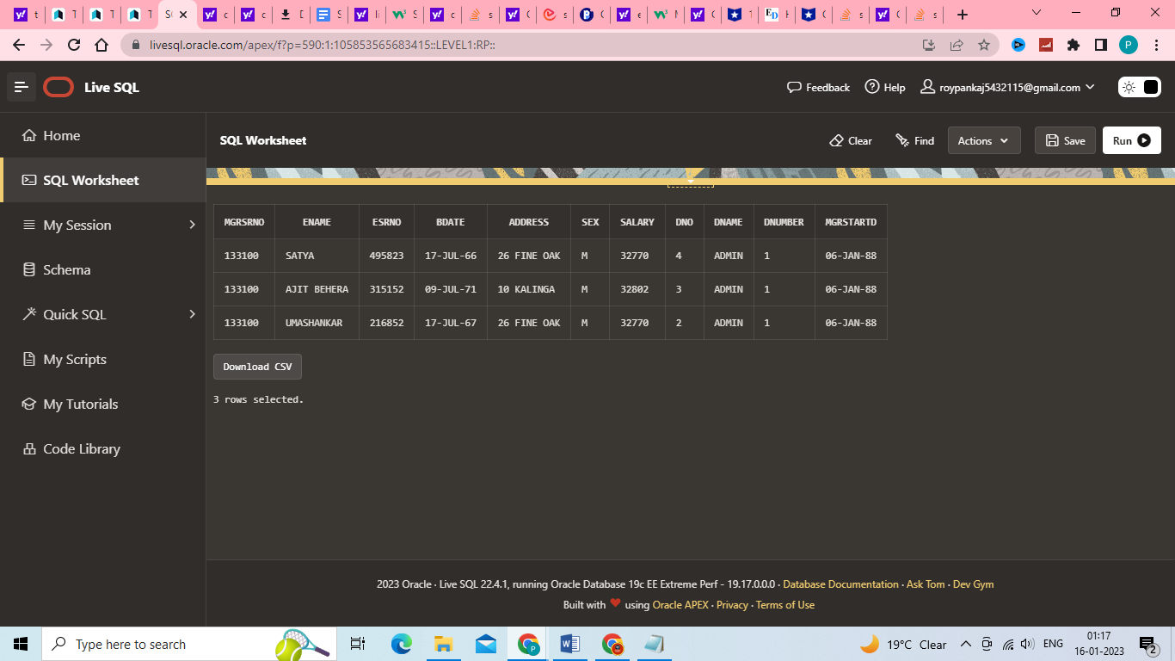

1. Display the name of all female employees.

<answer-here>select ENAME AS "Employee Name",sex from EMPLOYEE where sex='F';

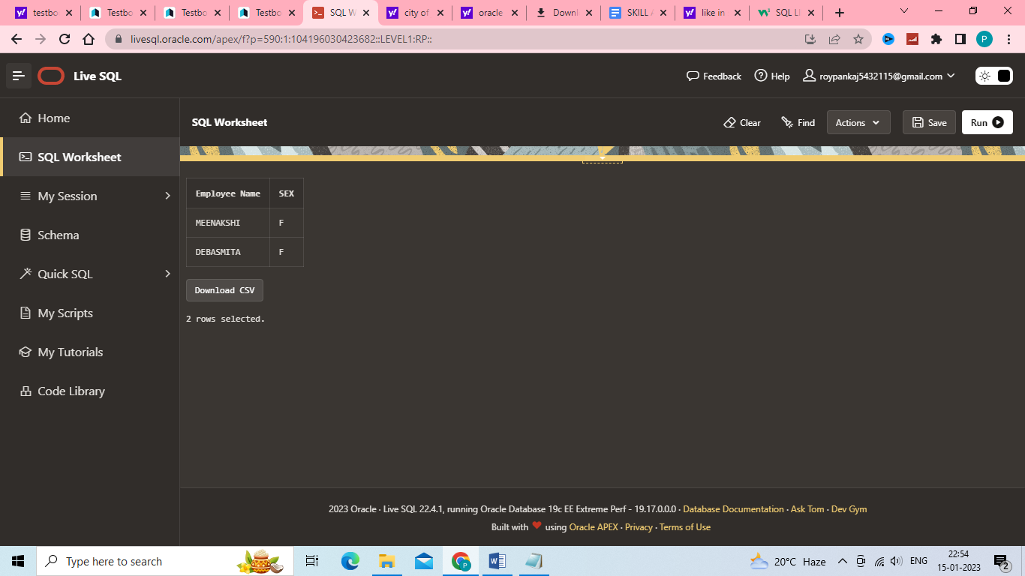Insert Image -

1. Display the employee who is paid most in the company.

<answer-here>select ENAME,SALARY from EMPLOYEE order by salary desc FETCH FIRST 1 ROWS ONLY;

Insert Image –

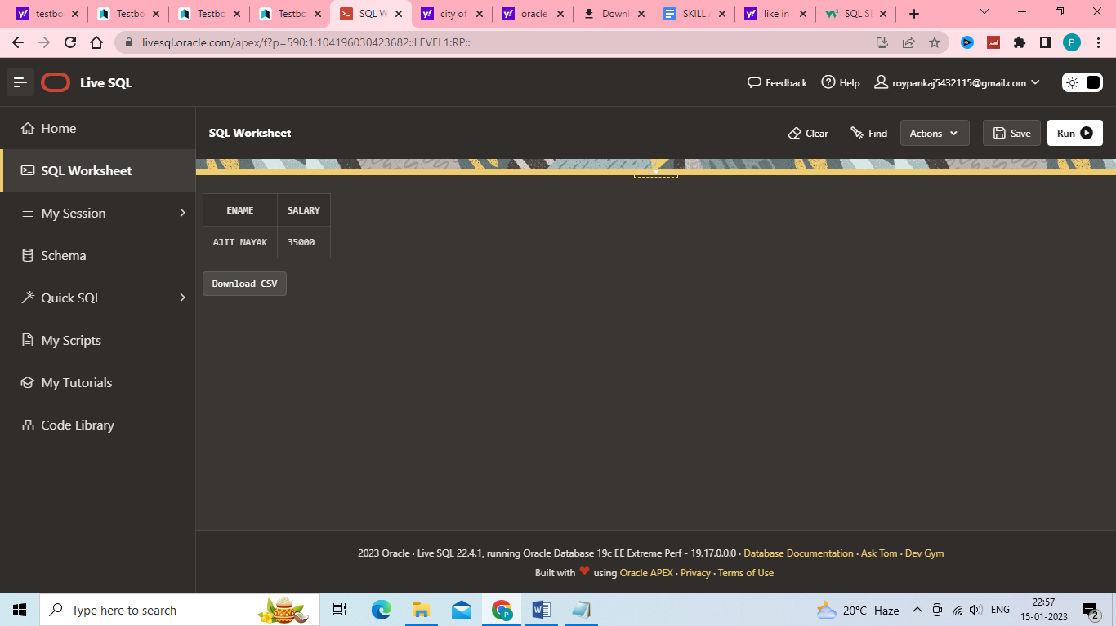

**Major Question 2**

1. Display employee name, address, department no and department name.

<answer-here> SELECT ENAME AS "EMPLOYEE NAME",ADDRESS,DNUMBER AS "DEPARTMENT NUMBER",DNAME AS "DEPARTMENT NAME" FROM EMPLOYEE e LEFT JOIN DEPARTMENT d on e.MGRSRNO=d.MGRSRNO;

Insert Image –

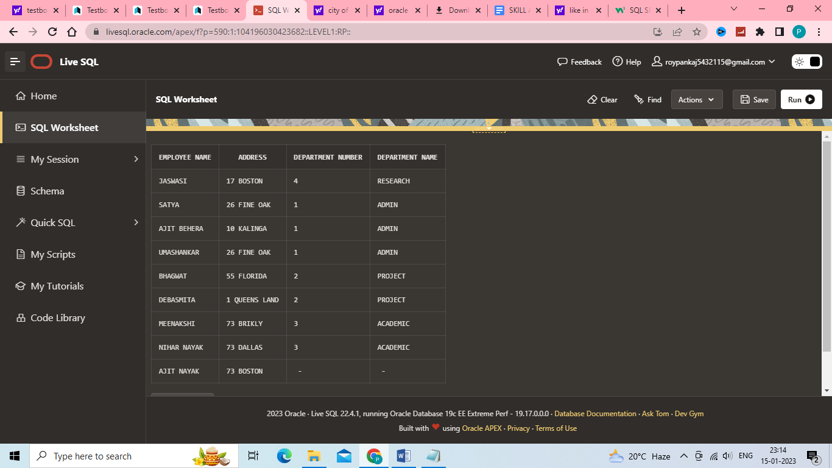

1. Display all the employees who are *not in* ACADEMIC department

<answer-here> SELECT ENAME AS "EMPLOYEE NAME",DNAME AS "DEPARTMENT NAME" FROM EMPLOYEE e LEFT JOIN DEPARTMENT d on e.MGRSRNO=d.MGRSRNO where DNAME!='ACADEMIC';

Insert Image –

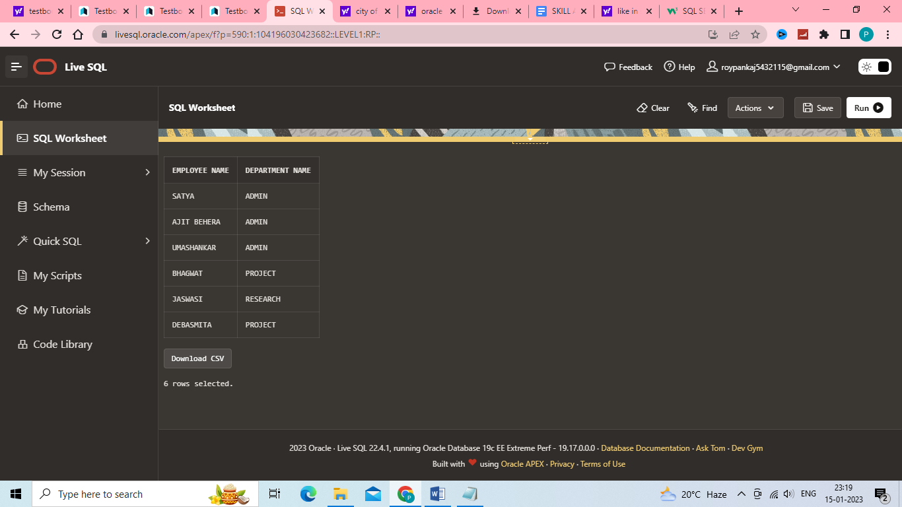

1. Display SATYAS’ project location.

<answer-here> select ENAME as "EMPLOYEE NAME",PLOCATION as "Project Location" from EMPLOYEE e inner join PROJECT p on e.DNO=p.DNUM where ENAME='SATYA';

Insert Image - 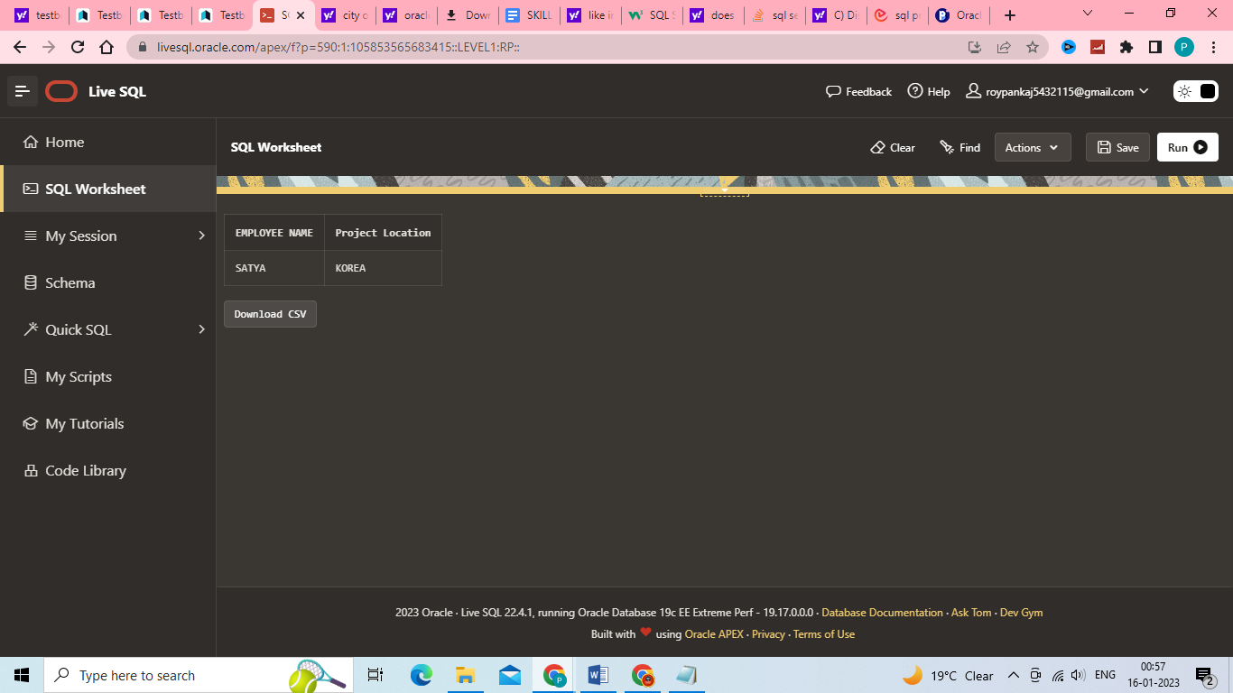

1. Find the total working hours of *each* female employee.

<answer-here>SELECT ENAME AS "EMPLOYEE NAME",SUM(HOURS) AS "TOTAL WORKING HOURS" FROM (select * from EMPLOYEE join WORKS_ON using(ESRNO) where SEX='F') GROUP BY ENAME;

Insert Image - 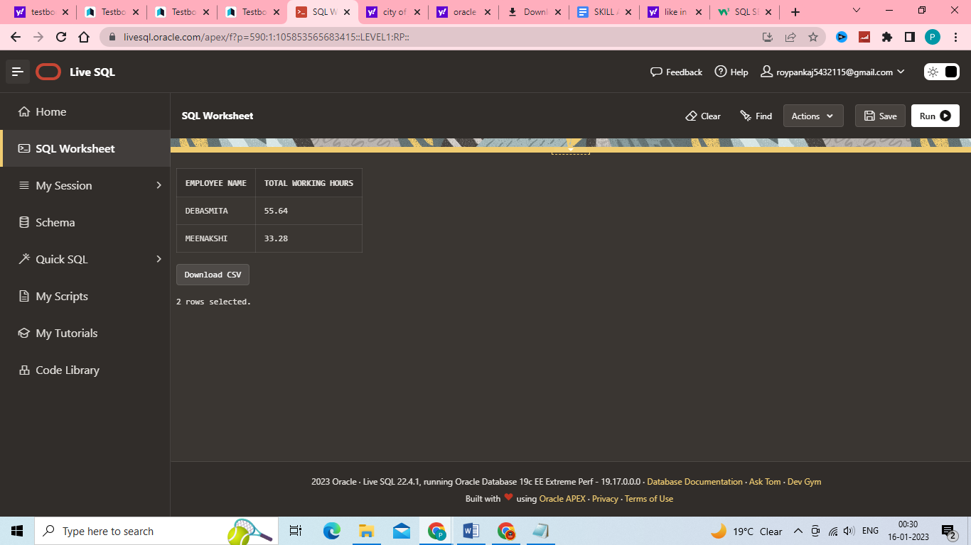

1. Display the details of the people whose projects are located at SOUTH AFRICA.

<answer-here> select * from EMPLOYEE e inner join PROJECT p on e.DNO=p.DNUM where PLOCATION='SOUTH AFRICA';

Insert Image - 